
2025 MULANJE DISTRICT JCE MOCK EXAMINATIONS
BIOLOGY
(100 marks)
Subject Number: J022

Wednesday, 2 April Time allowed : 2 hours
8:00 – 10:00

Instructions
Question Number | Tick if answered | Do not write in these columns
1 – 5
6 – 10
11 – 15
16 – 20
21
22
23
24
25
26
27
28
29
30
31
32
33
- This paper contains 10 printed pages.
Please check.

- This paper has three sections. A, B and C.

- Follow instructions for each section carefully.

- Write your examination number in the spaces provided on all the pages of this paper before you start answering the questions.

- In the table provided on this page, tick against the question number you have answered; 21 to 33.

- At the end of the examination, hand in
your question paper to the invigilator when
time is called to stop writing.

© 2025 Mulanje District mock Examinations Turn over/…

Section A (20 marks)
Answer all questions in this section. Encircle the letter corresponding to the correct answer. Each question carries 1 mark.

1. Which of the following parts of a cell regulates movement of substances in and out of a cell?
A. Cell membrane B. Nucleus
C. Cell wall D. Vacuole
2. In which form is glucose stored after the process of photosynthesis in plants?
A. Cellulose B. Proteins
C. Starch D. fats
3. What is the causative agent of genital warts?
A. Human Papilloma Virus
B. Herpes Virus
C. Trichomoniasis
D. Candida albicans
4. Which enzyme breaks down lipids into fatty acids and glycerol?
A. Trypsin B. Sucrase
C. Pancreatic lipase D. Salivary amylase
Figure 1 is a diagram showing a microorganism. Use it to answer questions 5 and 6.
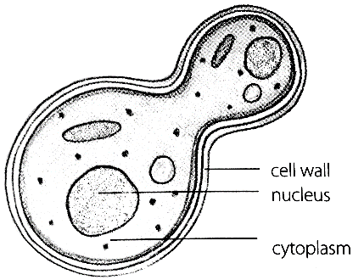
5. Name the microorganism.
A. Bacteria B. Virus
C. Paramecium D. Yeast
6. How does the microorganism reproduce?
A. Budding B. Fragmentation
C. Conjugation D. Regeneration

7. Which of the following is the function of a nose piece on a microscope?
A. To magnify the object under observation
B. To bring the object into sharp focus
C. To lift or lower lenses towards the object
D. To select the objective lenses
8. Which of the following is not a part of the appendicular skeleton?
A. Pectoral girdle B. Skull
C. Limbs D. Pelvic girdle
9. Which of the following chambers of the heart receives oxygenated blood from the lungs?
A. Left auricle B. Right auricle
C. Right ventricle D. Left ventricle
10. In which part of the alimentary canal does the digestion of proteins start?
A. Mouth B. Stomach
C. Duodenum D. Illeum
Figure 2 is an experimental set-up. Use it to answer questions 11 and 12.
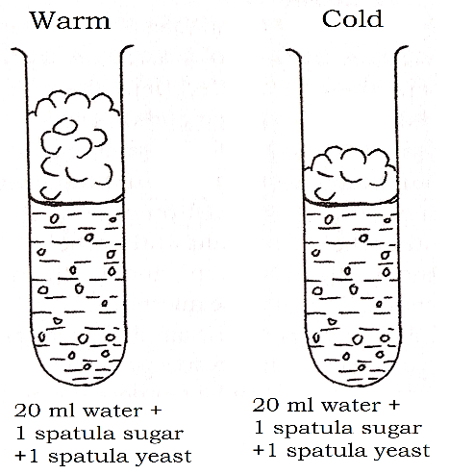
11. What is the aim of the experiment?
A. To investigate the effect of water on yeast growth

B. To investigate the effect of temperature on yeast growth
C. To investigate the effect of sugar on yeast growth
D. To investigate the effect of foam on yeast growth
12. Name the outcome variable for the experiment.
A. Temperature B. Sugar spatulas
C. Amount of water D. Amount of foam
13. Which of the following is a sign of threadworm infection?
A. Presence of worm segments in faeces
B. Passing out urine mixed with blood
C. Massively swollen legs, genitals and breasts
D. itching of the anus
14. Which part of the ear is responsible for regulating air pressure in the middle ear and the exterior air pressure?
A. semi-circular canals B. Cochlea
C. Eustachian tube D. Tympanic membrane
15. Which of the following is not the use of vitamin C in the body?
A. For cell metabolism
B. For absorption of iron
C. For healing of wounds
D. For maintenance of healthy cells and tissues
16. What is the name of the part of the brain that is responsible for maintaining body balance and posture?
A. Medulla oblongata B. Cerebellum
C. Hypothalamus D. Cerebrum
17. Which of the following is an example of conifer plants?
A. Liverworts B. Peas
C. Cypress D. Ferns
18. What is the recommended age range for a blood donor?
A. between 16 and 65 years
B. between 15 and 64 years
C. between 15 and 65 years
D. between 16 and 64 years
19. What is the effect of the contraction of the external intercostal muscles and diaphragm during inhalation?
A. Decreases volume of chest cavity and increases air pressure
B. Decreases volume of the chest cavity and decreases air pressure
C. Increases volume of the chest cavity and decreases air pressure
D. Increases volume of the chest cavity and increases air pressure
20. Which of the following is not a characteristic of arachnids?
A. Body divided into two segments
B. Compound eyes
C. Four pairs of jointed legs
D. No antennae

Section B (50 marks)
Answer all questions in this section in the spaces provided.
21. Figure 3 is a diagram showing a joint. Use it to answer questions that follow.

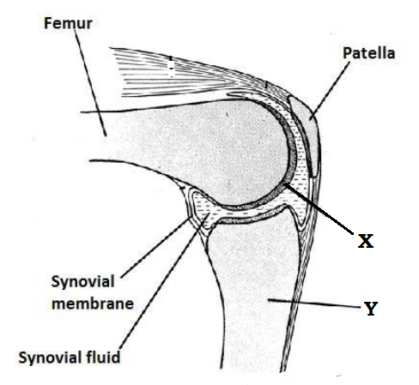
a. Name the parts labelled X and Y.
X: ____________________________ (1 mark)
Y: ____________________________ (1 mark)
b. Give two types of joints?
(2 marks) _____________________________________________________________________________________________________________________________________________________________________________________________________________________________________________________________________
c. What is the function of synovial fluid? (1 mark) ______________________________________________________________________________________________________________________________________________________________________________
d. Explain the difference between a sprain and a strain. (2 marks) _____________________________________________________________________________________________________________________________________________________________________________________________________________________________________________________________________
22. a. State the diarrhoeal disease that causes blood to appear in faeces in severe cases. (1 mark) ______________________________________________________________________________________________________________________________________________________________________________
b. Give two ways of preventing and controlling the disease stated in 22. a. (2 marks) _____________________________________________________________________________________________________________________________________________________________________________________________________________________________________________________________________
c. Explain one effect of sexually transmitted infections on the individual. (2 marks) _____________________________________________________________________________________________________________________________________________________________________________________________________________________________________________________________________

23. a. Give any two examples of monocotyledonous plants. (2 marks)
_____________________________________________________________________________________________________________________________________________________________________________________________________________________________________________________________________
b. Mention any two characteristics of dicotyledonous plants. (2 marks) _____________________________________________________________________________________________________________________________________________________________________________________________________________________________________________________________________
24. Figure 4 is a food web. Use it to answer questions that follow
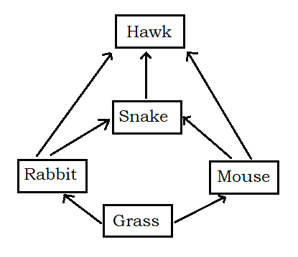
a. Identify one primary consumer from the food web? (1 mark) ______________________________________________________________________________________________________________________________________________________________________________
b. Construct one food chain with four organisms from the food web. (4 marks)

_______________________________________________________________________________________
c. Explain the role of grass in the food web. (2 marks) _____________________________________________________________________________________________________________________________________________________________________________________________________________________________________________________________________
25. a. State two guidelines that must be followed when making biological drawings. (2 marks) _____________________________________________________________________________________________________________________________________________________________________________________________________________________________________________________________________
b. Give any one structural difference between an animal cell and a plant cell. (1 mark)
_____________________________________________________________________________________________________________________________________________________________________________________________________________________________________________________________________
c. Magnification of a leaf drawing is X1.5 and the length of the actual leaf is 30 cm. Calculate the length of the drawing. (3 marks)

26. Figure 5 shows a chemical equation for the process of photosynthesis. Use it to answer questions that follow.
H₂O_{(l)} + P Q + O_{2(g)}
a. Give the chemical formulae for P and Q
P: _______________________________ (1 mark)
Q: _______________________________ (1 mark)
b. State one use of Q to the plant. (1 mark) ______________________________________________________________________________________________________________________________________________________________________________
c. Explain the function of P in the process of photosynthesis. (2 marks) _____________________________________________________________________________________________________________________________________________________________________________________________________________________________________________________________________
27. a. State two symptoms of anaemia. (2 marks) _____________________________________________________________________________________________________________________________________________________________________________________________________________________________________________________________________
b. Why does malaria cause anaemia? (1 mark) ______________________________________________________________________________________________________________________________________________________________________________
c. Explain why arterial bleeding is considered to be dangerous. (2 marks)
_____________________________________________________________________________________________________________________________________________________________________________________________________________________________________________________________________

28. State two effects of Indian hemp on the nervous system. (2 marks) _____________________________________________________________________________________________________________________________________________________________________________________________________________________________________________________________________
29. Figure 6 is a diagram showing internal structure of a tooth. Use it to answer questions that follow.
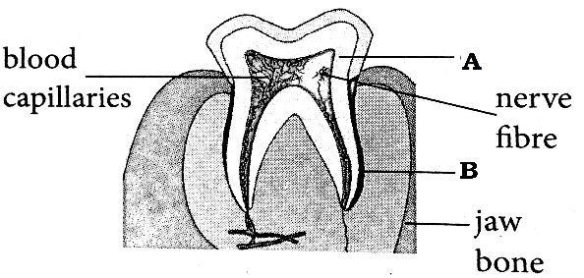
a. Name the parts labelled A and B.
A: __________________________ (1 mark)
B: __________________________ (1 mark)
b. Give one function for each of the two parts named in 29. a. (2 marks) ______________________________________________________________________________________________________________________________________________________________________________
c. Explain any one way of caring for teeth. (2 marks) _____________________________________________________________________________________
30. Give one function for each of the following parts of a leaf.
a. Guard cells (1 mark) _______________________________________________________________________________________
b. Xylem vessels (1 mark) ______________________________________________________________________________________
c. Cuticle (1 mark) _______________________________________________________________________________________

Section C (30 marks)
Answer all questions in this section. Your answers should be in an essay form.

31. Describe five defects of the eye. (10 marks) ______________________________________________________________________________________________________________________________________________________________________________________________________________________________________________________________________________________________________________________________________________________________________________________________________________________________________________________________________________________________________________________________________________________________________________________________________________________________________________________________________________________________________________________________________________________________________________________________________________________________________________________________________________________________________________________________________________________________________________________________________________________________________________________________________________________________________________________________________________________________________________________________________________________________________________________________________________________________________________________________________________________________________________________________________________________________________________________________________________________________________________________________________________________________________________________________________________________________________________________________________________________________________________________________________________________________________________________________________________________________________________________________________________________________________________________________________________________________________________________________________________________________________________________________________________________________________________________________________________________________________________________________________________________________________________________________________________________________________________________________________________________________________________________________________________________________________________________________________________________________________________________________________________________________________________________________________________________________________________________________________________________________________________________________________________________________________________________________________________________________________________________________________________________________________________________________________________________________________________________________________________________________________________________________________________
32. Explain five characteristics of living things (10 marks) ______________________________________________________________________________________________________________________________________________________________________________________________________________________________________________________________________________________________________________________________________________________________________________________________________________________________________________________________________________________________________________________________________________________________________________________________________________________________________________________________________________________________________________________________________________________________________________________________________________________________________________________________________________________________________________________________________________________________________________________________________________________________________________________________________________________________________________________________________________________________________________________________________________________________________________________________________________________________________________________________________________________________________________________________________________________________________________________________________________________________________________________________________________________________________________________________________________________________________________________________________________________________________________________________________________________________________________________________________________________________________________________________________________________________________________________________________________________________________________________________________________________________________________________________________________________________________________________________________________________________________________________________________________________________________________________________________________________________________________________________________________________________________________________________________________________________________________________________________________________________________________________________________________________________________________________________________________________________________________________________________________________________________________________________________________________________________________________________________________________________________________________________________________________________________________________________________________________________________________________________________________________________________________________________________________
33. Explain any five functions of blood. (10 marks) ________________________________________________________________________________________________________________________________________________________________________________________________________________________________________________________________________________________________________________________________________________________________________________________________________________________________________________________________________________________________________________________________________________________________________________________________________________________________________________________________________________________________________________________________________________________________________________________________________________________________________________________________________________________________________________________________________________________________________________________________________________________________________________________________________________________________________________________________________________________________________________________________________________________________________________________________________________________________________________________________________________________________________________________________________________________________________________________________________________________________________________________________________________________________________________________________________________________________________________________________________________________________________________________________________________________________________________________________________________________________________________________________________________________________________________________________________________________________________________________________________________________________________________________________________________________________________________________________________________________________________________________________________________________________________________________________________________________________________________________________________________________________________________________________________________________________________________________________________________________________________________________________________________________________________________________________________________________________________________________________________________________________________________________________________________________________________________________________________________________________________________________________________________________________ END OF QUESTION PAPER
This paper contains 10 printed pages.

